Java Features

- Simple
Java is simple as it contains lots of APIs (Application Programming Interfaces) / Libraries

Ex.
- Arrays.sort(n);

- Object Oriented
Java is Object Oriented (OO) as it supports all the OO features like Objects, Classes, abstraction, encapsulation, inheritance and polymorphism

- Robust
Robust means Strong
In Java we can develop robust applications using Exception handling which avoids abnormal termination of application

- Platform Independent

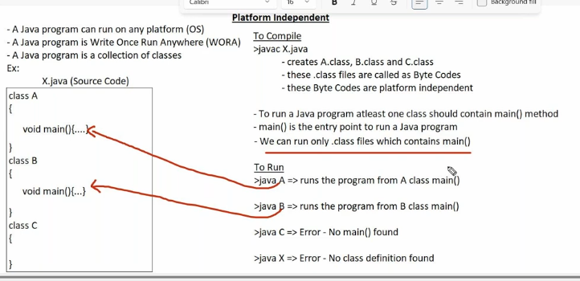

- Interpreted
Java command is an interpreter
Java interpreter executes the byte code line by line
javac command is a compiler
java compiler converts java source code into byte code at a time

- Portable
Java is portable since the size of respective data types is same on all platforms

- C/C++
Size of int data type 2 bytes on 32-bit/4 bytes on 64-bit OS

- Java
Size of int data type 4 bytes on 32-bit/64-bit OS

- Secure
Java is secure as Java does not support pointers as Pointers violate security

C/C++
A Pointer is a variable which contains address of another variable
Ex.
Int n = 10;
Int *p = &n; // addr of n variable

- Multithreaded
A thread is a light weight process under execution within a process
Multithreading is used to increase the performance of application
Running multiple tasks at the same time inside one program.

- Dynamic
Memory allocation for arrays, objects is done during runtime (dynamic)
Java is automatic garbage collection

- Distributed
Distributed applications are used for the purpose of exchanging data from one application to another application

